CET 101 Fundamentals of Computing 2019-20 Assessment 3

## Professional practice week: 13th of January

In this assessment, we are assessing the skills you have developed so far in the following areas:

* Understanding of standards, formats and tools used in the design of information, multimedia and web-based systems
* Recognition of the need for adaptable approaches to problem solving
* Ability to specify and contextualise a problem and communicate effectively an appropriate solution to a range of audiences
* Use of software engineering techniques to design, code, test and evaluate a range of software solutions
* Appraisal of the fundamental operation of computer systems, network architectures, hardware components, operating systems and associated protocols and data structures

**All of this work is to be completed individually.**

**This assessment is taking place as a Full Professional Practice Week.**

**Your problem will be issued at 9am Monday and you will submit by 9am Friday. This means you have 4 working days to complete it. We assume that 4 working days means 7 hours per day (as if you are working a full time job, 9am-5pm with lunch break), and your tutor and moderator have agreed that the task should take no longer than 28 hours.**

## Justification

Cycling has seen a massive increase in popularity across the world in recent years, especially in the UK. Not only does it have health benefits but it also is currently having a positive effect on the economy, with more and more people spending their money on the latest bikes, accessories and clothing. Cycle holidays are more popular than ever and have overtaken golfing as the activity holiday of choice for the UK. With the rise of cycling sees the rise in cycling related fitness equipment and technology. Smart turbo trainers now let you compete virtually against people online from the comfort of your own home, smart exercise bikes rank and score you against other competitors and apps track your cycle routes and count your miles for online leaderboards.

## Background

Cities across the UK have decided to host a national cycling competition where individuals or cycling groups can compete against each other to be crowned an overall winner or winners.

The event will be called Cit-E Cycling.

The format of the event will be that ten mini pop up tournaments are to be held across the city in different locations and each event will last for 3 days. There will be 20 high tech exercise bikes that will be able to track how many miles you have cycled and your power output. This data will then be used to rank the different participants against each other. Participants must book an hour time slot in advance so that they can come to the event and compete. Each participant is only allowed to enter the competition once and they have the option of entering as part of a cycling group or as an individual. Prizes will be awarded for the different age categories, different genders and for the best performing cycle group.

Winning participants will then be invited to compete for their city in a national event that pitches the cyclists from each city against each other.

## Problem

The organisers realise that this event is going to require expertise in a lot of different areas such as software engineering, website development, networking, programming and systems design if the event is to be successful. It will be your responsibility to ensure that each problem has been tackled effectively and that a solution that meets the needs of the client has been provided.

Bear in mind the ethical issues that may present themselves and be sure to conduct yourself professionally. Be aware that you are required to work under the university’s IT acceptable use policy which you can access [here](https://my.sunderland.ac.uk/display/SH/IT+Acceptable+Use+Policy). Note in particular under internet unacceptable use:

* 3.4 Use, transmission, duplication, or voluntary receipt of material that infringes on the copyrights, trademarks, trade secrets, or patent rights of any person or organisation. All users must assume that all materials on the Internet are copyright and/or patented unless specific notices state otherwise.
* 3.6. Creation, posting, transmission, or voluntary receipt of any unlawful, offensive, libellous, threatening, harassing material, including but not limited to comments based on race, national origin, sex, sexual orientation, age, disability, religion, or political beliefs.

## Your Tasks

Task 1: Virtual Machine 40%

The organisers have been approached by several schools who would like to have “local” competitions within the school. The schools are concerned about security and keeping data on the children safe. As such, they would like to set up their own server not connected to the internet.

The organisers feel that this will be best accomplished using a virtualised LAMP server for each school. They would like you to create a guide which can be freely be distributed to schools giving them step by step instructions on how to download and “spin up” a virtualised LAMP server. These should be supplemented by screenshots (use the Windows snipper tool) for each step so that they can be easily followed by the School technicians.

**It is recommended that you complete this assignment using the University's computers in DG118, therefore, if you wish to use your own pc/laptop, you will need to configure it accordingly yourself.**

**Marking criteria:**

For each of the above tasks marks will be allocated as follows:

**1-19** marks will be allocated for an adequate piece of work that captures some of the relevant steps in downloading and “spinning up” a LAMP server. This will include some screenshots.

**20-29** marks will be allocated for a good piece of work that captures most of the relevant steps in downloading and “spinning up” a LAMP server. Which is presented in a professional way that can be understood by most of the school technicians; most steps supported by relevant screenshots.

**30-40** marks will be allocated for an excellent piece of work that captures all of the relevant steps in downloading and “spinning up” a LAMP server. Which is presented in a professional way that can be understood by all of the school technicians and other stakeholders; all steps supported by relevant screenshots. This will include steps (and screenshots) showing how to upload and display a relevant webpage.

**Helpful Information:**

******************** Part A – Create your Virtual Machine ************************

Log in to your PC, open up your browser. Set your browser settings to download the file to the storage location (in Chrome click the settings icon, then advanced then download location). Once you have changed this, navigate to the following URL:

<https://marketplace.vmware.com/vsx/solutions/turnkey-lamp-appliance>

This will download a prebuilt LAMP server as an ova file. This will download to the storage location.

Fire up VMWare and select open a VM, then navigate to the ova file. **Please note that there is a risk of failure here due to the network settings not being correctly configured.** Once the VM has started, you will need to shut it down using the power options from the menu bar or the menu. Edit the network settings and change to NAT.

You should now be able to power up the VM and it will work correctly. **At some point you will be asked to create a password we strongly suggest you use (CET101cet101).** Once you have been prompted for passwords, you will eventually see a screen as below:

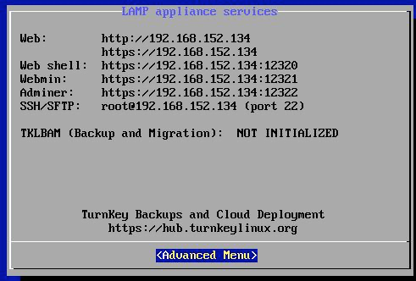

Once you have this, you should be able to return to the host operating system, enter the web IP address and you should see the following:

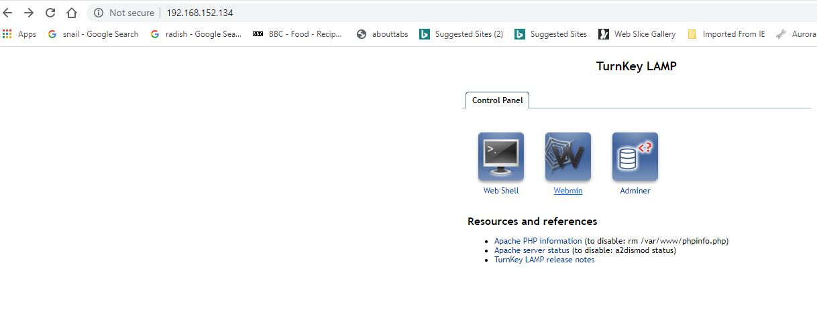

***************** Part B – Uploading files to your Virtual Machine ******************

This requires the use of filezilla (available from<https://download.cnet.com/FileZilla/3000-2160_4-10308966.html>). This should be installed in the lab.

Open up filezilla on the host machine and enter the details you have been given (IP address), the user is root, the password will be (CET101cet101) if you set it. The required port is 22. See below.

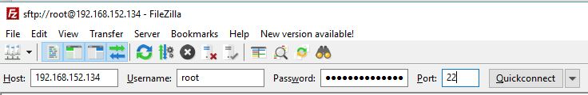

You then have 4 panes:

· Left top – local directories

· Left bottom – local files

· Right top – Remote directories

· Right bottom – Remote files

On the remote machine, you can navigate to /var/www. You can then upload html files to here.

View these by appending html file name to the IP address in the host browser e.g.<https://192.168.152.134/firstpage.html>

**End of additional information.**

**Submission information**

Submit the guide as a word document to the “Assignments section” in Canvas by 9am on Friday the 17th of January.

### 

### Task 2: Database development 40%

**Important information!**

**To avoid complications with XAMPP and phpMyAdmin on some user accounts, we recommend that while you are working on your database, you export it as an SQL file so you can import it if you want to continue working on it later, either on the labs or at home.**

Part A: Database creation and population (worth 20%)

The event organisers are going to need a database to store data for all of their participants, clubs and events.

They would like you to create a relational MySQL database using phpMyAdmin.

The database should have the following tables:

* Participants
* Clubs
* Events

The tables should have the following relationships:

* One event can have many participants but a participant can only register for one event.
* One club can have many members but a participant can only be a member of one club.

A simplified database diagram is illustrated below:

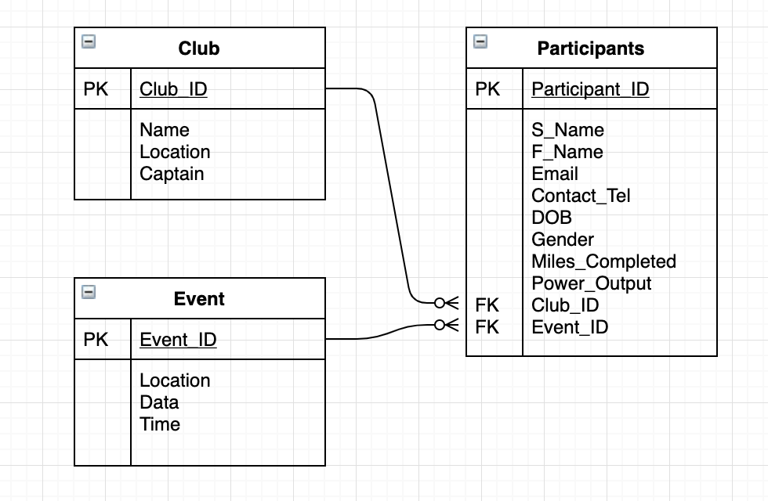

**It is your job to decide the properties, values and data types will be for each field.**

**You are also required to populate the database with relevant test data and the number of records required for each table is specified below:**

* 20 Participants
* 3 Events
* 5 Clubs

Please submit a report including two screenshots from phpMyAdmin for each table. One screenshot showing the **data** in the table and one showing the **structure** of the table.

Part B: Database queries (worth 20%)

To test the validity and efficiency of the database you are required to create and run some queries using MySQL.

Please create and run the following queries:

1. Select all of the participants who are male
2. Select all the female participants who are registered to a club
3. Select all the participants who are under the age of 18
4. Register a new participant
5. Change the miles completed for a participant
6. Select all of the participants for a certain event
7. A club has been disqualified for cheating. Delete all of the members for a particular club using just one query
8. An email needs to be sent to all of the participants for a particular event. Select just the email address for participants of a particular event.
9. A club has changed its name. Write a query to demonstrate this.
10. An event has changed its date. Write a query that changes the date of an event.

**For each query please include the MySQL you used as well as a screenshot of the results from phpMyAdmin.**

#### Marking Criteria

|  |  |  |  |
| --- | --- | --- | --- |
| Task | **High Marks** | **Mid Marks** | **Low marks** |
| Database creation and configuration | **11-15**  Correctly created database tables with correctly configured fields with appropriate and efficient use of data types. | **5-10**  Database tables may contain errors and the use of data types might not be efficient but database still functions | **0-4**  Database with incorrect or missing tables and poor use of data types. |
| Database population | **4-5**  All tables populated with the correct quantity of records and all data is relevant | **2-3**  Not all data is relevant and some tables might not have the required quantity | **0-1**  Data is not relevant and falls short of what is required. |
| Database queries | **14-20**  A very good or excellent attempt at all ten queries with correct or nearly correct syntax across the range. | **7-13**  An average or good attempt at all ten queries. All queries run but could have been more efficient. | **0-6**  A poor attempt at creating the queries where some might be missing or incorrect. |

#### Submission Information

Please create one report in PDF format including parts A and B and submit it to the “Assignments section” in Canvas by 9am on Friday the 17th of January.

### 

### Task 3: Reflection 20%

Now that you are almost half way through your first year, you will have completed a significant number of lab activities / tutorials for all of your strands.

I would like you to pick 3 different activities that you have completed and reflect on what you have learnt from them. These activities should be from 3 different strands. This does not include any work you have already done in a PPW assessment or for other modules.

For each activity please answer the following 3 points:

* What did the task require you to do?
* What problems did you overcome when you were completing this task?
* What did you learn from the task, and where have you since applied this new skill or knowledge?

The finished piece of reflection should be in the region of 750 words and you are free to include screenshots.

#### Marking Criteria

|  |  |  |  |
| --- | --- | --- | --- |
| Structure, spelling and grammar | High marks  A well written reflective report with correct use of spelling, punctuation and grammar. | Mid marks  A report that makes a good attempt at being well structured but includes some spelling, punctuation and grammar errors. | Low / No marks  A poorly written report with many spelling, punctuation and grammar issues. |
| Marks | 5 - 4 | 2 - 3 | 0 - 1 |
| Reflection | High marks  A well written reflective report where you have been able to reflect on work completed and the lessons you have learnt from it | Mid marks  A good attempt has been made to reflect on previous tutorial work. | Low / No marks  A report that includes little or no reflection and falls short of what is required. |
| Marks | 11 - 15 | 6 - 10 | 0 - 5 |

### 

### Submission Information

Please complete this activity as a new page entitled “Professional practice week 3” on your ePortfolio, in the “First year assessments” category.

Submit the **public link** to the assignments section on canvas.

Ensure that your reflection is written on the page, and **not a linked document**. Make sure the correct link is submitted. It is recommended that you test this link after you have logged out of canvas to ensure that it is viewable.

### 

### Submission information

All tasks are to be submitted to Canvas by 9am on Friday the 17th of January.

This excludes anyone who has additional time due to having a support memo in place.

Please see the individual tasks for specific submission requirements such as naming conventions, file formats etc.